

The Guide to Implementing the Federal Competency Assessment Tool - Management

How to Apply the Federal Competency Assessment Tool - Management in Your Agency

Version 2.1

June 24, 2008

Developed for:
The U.S. Office of Personnel Management (OPM)
Division of Human Capital Leadership and Merit Systems Accountability (HCLMSA)

Developed by:
Booz Allen Hamilton
Table of Contents

1. Introduction 4
1.1 Purpose 4
1.2 FCAT-M Overview 4
1.3 Feedback on the Implementation Guide 4
2. FCAT-M Implementation Guidance and Instructions 5
2.1 Introduction 5
2.2 High Level Process Overview 5
2.3 Pre-Assessment Phase 6
2.3.1 Conduct Consultative Meeting with OPM 6
2.3.2 Develop FCAT-M Assessment Project Plan 7
2.3.3 Obtain Agency POC FCAT-M Account 8
2.3.4 Access FCAT-M 8
2.3.5 Identify Target Population for Assessment Participation 8
2.3.6 Confirm Organizational Structure 9
2.3.7 Identify and Conduct Outreach Activities 9
2.3.8 Assess Union Implications 10
2.3.9 Notify Target Population 10
2.4 Assessment Phase 11
2.4.1 Launch Assessment 11
2.4.2 Monitor Participation 11
2.4.3 Provide First-Line Assistance 11
2.4.4 Send Participation Reminders 12
2.4.5 Conclude Assessment 12
2.5 Post-Assessment Phase 12
2.5.1 Analyze Representativeness 12
2.5.2 Analyze Results 13
3. Using FCAT-M as an Agency POC 14
3.1 Introduction 14
3.2 Gaining Account Access 14
3.3 Logging In 14
3.4 Signing Out 15
3.5 Changing Your Password 15
3.6 Conducting a Self Assessment 15
3.7 Conducting a Supervisory Assessment 17
3.8 Assessment Results Report 19
3.9 Additional Features 20
3.9.1 Main Menu 20
3.9.2 Help 21
3.9.3 Site Information 21
3.10 Accessing Other Reports 22
3.10.1 Average Competencies Report 24
3.10.2 Profile Reports 24
Appendix A: FCAT-M – Activities Checklist 25
Appendix B: FCAT-M Communications Kit 28
B.1 Introduction 28
B.1.1 What is Included in the FCAT-M Communications Kit 28
B.2 Purpose, Instructions and Timing of Communications 28
B.2.1 Pre-Launch E-mail 28
B.2.2 Launch Day E-mail 28
B.2.3 Weekly Reminder E-mail 29
B.2.4 Assessment Pre-closure E-mail 29
B.2.5 Assessment Closure E-mail 29
B.2.6 Tips for Increasing Response Rates 30
B.2.7 Motivating Messages 30
B.2.8 Other Points to Remember 30
B.3 Pre-Launch Email 30
B.4 Launch Email 32
B.5 Weekly Reminder E-mail 33
B.6 Assessment Pre-Closure Email 33
B.7 Assessment Closure Email 34
B.8 Tips for Increasing Response Rates 34
B.9 Motivating Messages 34
Appendix C: Frequently Asked Questions 37
Appendix D: Competencies and Rating Scales 38
D.1 Leadership Competencies 38
D.2 Performance Management Competencies 39
D.3 Generic Proficiency Rating Scale 40
Appendix E: Demographic Questions for Registration 41

1. Introduction

1.1 Purpose
This document assists Agencies in their preparations for and conduct of an assessment using the Federal Competency Assessment Tool - Management (FCAT-M). It describes the various phases in performing an FCAT-M assessment as well as the various steps within each phase. The document also contains a comprehensive checklist to ensure that designated Agency points of contact (POCs) are adequately prepared to conduct the assessment, as well as other useful materials and resources (such as a FCAT-M User’s Guide, Communications Kit, etc.). Finally, the document describes how the U.S. Office of Personnel Management (OPM) is prepared to assist Agency POCs during the assessment.

1.2 FCAT-M Overview
The Federal Government is making a concerted effort to ensure its leaders have the necessary skills to manage a 21st century workforce and to guarantee our leadership pipelines position us for future success. Recently, the OPM revised the Executive Core Qualifications for the Senior Executive Service (SES) cadre and issued guidance for managerial development. To further support agencies in these efforts, we are pleased to offer the FCAT-M, which officially launched June 16, 2008

The FCAT-M is a Web-based instrument for assessing the skill levels of managers, supervisors, team leaders, and others in key leadership and performance management competencies. It allows an individual to conduct a self assessment and receive a supervisory assessment to determine competency strengths and areas for improvement. Agencies can use the results of the assessments to support their leadership competency gap analysis, succession management, and development efforts. In addition, the FCAT-M enables OPM to report on the health of the leadership cadre government-wide and establish benchmarks for executives, managers, and supervisors.

1.3 Feedback on the Implementation Guide
Your feedback regarding this guide is critical to ensure that it adequately addresses all relevant aspects of FCAT-M implementation in a clear and useful manner. If you have any suggestions for improvement or areas where further instruction and/or guidance might be warranted, please contact the OPM FCAT-M Project Team Lead, Angela Graham Humes at 202-606-2430 or email at Angela.GrahamHumes@opm.gov.
2. FCAT-M Implementation Guidance and Instructions

2.1 Introduction
This section explains the processes involved in implementing a FCAT-M assessment, defines the phases and specific activities involved during implementation, delineates roles and responsibilities, and provides guidance, instructions and templates to support Agency Points of Contact (POCs) in their implementation activities. Materials that support the implementation process are located in the Appendices and will be referred to as appropriate.

2.2 High Level Process Overview
The graphic below illustrates (at a high-level) the major FCAT-M assessment phases (Pre-Assessment, Assessment and Post-Assessment), activities associated with each phase (generally listed in sequential order), and an anticipated time frame to complete each phase in the overall assessment. The sections that follow provide additional detail regarding the specific activities within each phase.

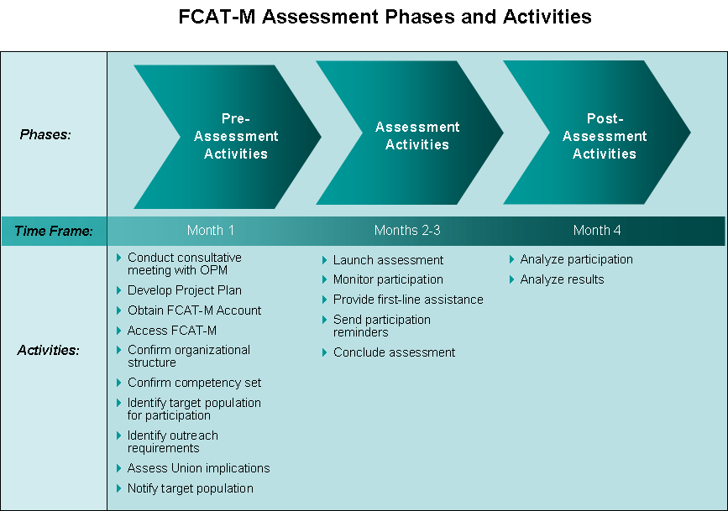

2.3 Pre-Assessment Phase
The Pre-Assessment Phase includes activities generally associated with preparing for the actual assessment, such as formulating a plan for rollout, gathering and validating required information, and initiating some communications. Specific activities in this phase are outlined in greater detail below.

2.3.1 Conduct Consultative Meeting with OPM

OPM is extremely cognizant of the need for an effective partnership between it and participating Agencies to make the Management Competency Assessment a productive and useful effort. Central to this partnership is a clear understanding of how the assessment is to be orchestrated, the steps in the assessment process, delineation of roles and responsibilities, and support OPM is committed to provide Agencies. To ensure the assessment “gets off on the right foot,” we recommend having a consultative meeting with OPM as the first activity that takes place in the Pre-Assessment Phase. This meeting is optional and could be accomplished either face to face or via telephone.

Agencies that choose to utilize the FCAT-M to perform their assessment of Leadership and/or Performance Management Competencies should work with their agency Human Capital Officer (HCO) to coordinate and schedule a consultative meeting.

The consultative meeting serves as a kickoff of the assessment effort. It is the first opportunity for HCLMSA to explain how the assessment should proceed, and showcase the tools and resources available to assist Agency POC(s). A typical agenda for the consultative meeting will include:

- Overview of the FCAT-M and associated assessment process (phases), to include roles & responsibilities, support available from OPM, timelines, etc.
- Detailed demonstration of the FCAT-M assessment tool, including its features and reports
- Review of Implementation Guide
- Discussion of the data that the Agency will need to collect, validate and provide to OPM
- Confirmation of Agency POC(s)
- Establishment of a regularly scheduled status update meeting
- Initial discussion of assessment project timeline
- Question & answer session
- Determination of action items
The consultative meeting should take less than two hours. In order to ensure you are adequately prepared for this meeting, it is highly recommended that you review this Implementation Guide, including the checklist in Appendix A, so that you have a foundational understanding of the assessment process and can prepare questions in advance so that your concerns are addressed during the meeting. In addition, it is imperative that all individuals servings as Agency points of contact for this effort be in attendance.

In addition, to prepare for the remaining activities in the Pre-Assessment phase, you should start thinking about answers to the following questions, or how you plan to collect the information needed:

- What strategic priorities are driving leadership development and succession management strategies in your agency?
- What leadership positions and competencies have your organization targeted in the past? What leadership competency model (e.g., OPM leadership competencies (ECQ-based)) does your organization use?
- How are you currently assessing the skill/proficiency level of your leaders? What, if any, issues have you had with using this method? What are the agency’s experiences (positive and negative) with launching assessment tools?
- Based on your program needs and what you know about the Federal Competency Assessment Tool – Management, how can the tool be used to support your organization?
- What is the scope/size/scale of the leadership workforce? What leadership positions are anticipated to be targeted?
- Will your agency be assessing against all (28 leadership competencies and 6 performance management) competencies or just the performance management competencies?
- What is your timing for rolling out the tool? What do you see as the best way to introduce the tool into your organizational environment/culture?
- What kind of technology does your agency have?
- Are the point(s) of contact within your agency identified and confirmed?
- Will your agency want to “lock down” access to account registration?
- Do you foresee any barriers to successful administration of this assessment?
- Have all agency points of contact (POCs) received training on handling personally identifiable information?

2.3.2 Develop FCAT-M Assessment Project Plan
Upon conclusion of the consultative meeting, the next step is the formulation of an assessment project plan. This is an important document that establishes major milestones (such as the assessment start and end dates); outlines discrete assessment activities, interrelationships and dependencies; and ensures the proper timing of assessment events.

The project plan should also take into consideration and document assumptions about the assessment and identify risks and associated mitigation strategies. This will help ensure successful assessment project performance.

The Agency POC will be responsible for the development of the project plan, but should rely on guidance and assistance from the OPM HCO and FCAT-M Project Team to ensure it is comprehensive, accurate and realistic. The project plan should be updated as needed if events dictate schedule or other changes.

2.3.3 Obtain Agency POC FCAT-M Account
The FCAT-M contains specific user profiles that allow the system to restrict access to certain features and tools. Agency POC(s) will have special privileges on the FCAT-M system that will allow them to gain access to additional documentation in the ‘Help’ section of the tool, as well as an entire section on ‘Reports’ that will help track participation (during the Assessment Phase) and perform certain analyses (during the Post-Assessment Phase). See Section 3.10 for further information.

The FCAT-M administrator will establish accounts and set up the appropriate privileges for identified Agency POCs, and will notify each POC by email when this is complete. This will be based on the names of POCs provided per section 2.3.1; any additions or changes should be brought to the attention of the OPM FCAT-M Project Team. Once account information has been received by Agency POCs, they should immediately log in to the FCAT-M and notify the OPM FCAT-M Project Team of any problems accessing the tool. New accounts can be added at any time, as needed. Finally, Agency POCs should notify the OPM FCAT-M Project Team if specific Agency POCs no longer require access to the site.

Agency POCs should refer to Section 3 of this Implementation Guide. This section explains how to log in and use the FCAT-M, including its reporting features. The guide also contains instructions on how a typical “user” would interact with the FCAT-M. This is provided so that POCs understand how the FCAT-M is used so they can provide assistance to users, and in case the POC is also participating in the assessment.

2.3.4 Access FCAT-M

Once you have been notified that your FCAT-M POC account has been established, please access it to ensure that the login works and you have been given the appropriate access privileges. Please refer to Section 3 of this Guide for login instructions.

If your account has been properly configured, you should have a tab titled ‘Reports’ that you can access to view certain reports. Please click on this tab and run each report, ensuring that the results contain only those records that belong to your respective organization. If (a) you do not have or cannot access a Reports tab, or (b) the results of reports contain records that do not belong to your organization, please contact the OPM FCAT-M team immediately.

2.3.5 Identify Target Population for Assessment Participation

The target population is for the assessment is executives, managers, supervisors, team leaders, or any individual in a leadership position. It is important for the Agency POC to understand the size of the target population so an accurate response rate can be calculated. The response rate is the percentage of employees that have been targeted for participation that have completed an assessment. Agency POCs can access Reports to get an accurate, real-time tally of the total number of completed assessments (both self and supervisory) for their organization. This total can then be compared to the target population to calculate the response rate.

It is also important for the OPM FCAT-M team to understand the target population so a Government-wide response rate can be calculated, and so that (in some cases) large populations can be planned for with respect to balancing the load on the web-based tool.

During the initial consultation meeting, you may discuss the method used to identify your target workforce. Once that workforce has been identified and quantified, please be sure to record the target number and provide to the OPM FCAT-M Project Team. Keep in mind that target numbers may change over time, so depending on how long you plan to conduct the assessment, you may need to recalculate the target.

One final consideration regarding the target population is to determine the preferred method for communicating with participating employees. While in most cases this will be via email, it must be determined if valid email addresses exist for those employees. If email is to be the method (which is recommended), the Agency POC should work with their IT staff to develop an email distribution list at this time.

2.3.6 Confirm Organizational Structure

The FCAT-M includes a three-tiered organizational structure to help identify the specific Department/Agency, reporting Bureau/Office, and sub components where an FCAT-M assessment participant works. This information is entered by the participant during the FCAT-M account registration process, first by selecting the appropriate Department/Agency they work for, then the associated Bureau/Office, from drop-down boxes pre-populated with the organizational structure data.

The OPM FCAT-M Project Team will provide a listing of the Agency’s organizational structure. The Agency POC must review the structure and provide any requested changes to the Project Team no later than two weeks prior to the scheduled assessment launch date. This will allow sufficient time to incorporate and test the requested changes.
Note: Once the assessment commences, organizational level changes cannot take place; it is very important to ensure the accuracy of the data prior to launch.

2.3.7 Identify and Conduct Outreach Activities

Prior to launching the assessment, it is important to understand the various stakeholder and their communication needs, so they are aware of the logistics of the assessment and fully prepared to participate (as appropriate). It is recommended that Agency POCs first identify and list the various stakeholder groups. Next, determined the specific information needs for each of these groups. For example, certain elements of your organization (such as Agency leadership) might require a formal briefing presentation.

A sample listing of stakeholder constituencies includes:

- Participating Employees
- Supervisors of Participating Employees
- Agency Leadership
- Human Capital/Human Resources Office
- Unions (see section 2.3.8 below)

Once you determine stakeholder constituencies and their information needs, formulate a “tactical plan” for conducting outreach activities. While you should plan most initial outreach activities so they are completed prior to the launch of the assessment, keep in mind that you should keep some constituencies informed at various points along the assessment timeline. In other words, communications does not stop at the beginning of the assessment; communications can include regular status updates as well as – once the assessment concludes – an indication of how well the Agency has performed and how the results will be used.

A useful source of communications to participating employees is the communications kit that is provided in Appendix B. In addition, the Frequently Asked Questions provided in Appendix C should be useful in providing some background information about the FCAT-M. Finally, the OPM FCAT-M Team may have additional materials (e.g., briefing presentations, one pagers, etc.) that may be useful for this purpose.

2.3.8 Assess Union Implications

Those agencies with bargaining unit employees should determine if union interaction and communication is required. If a determination is made that union concerns need mitigating, the agency should work through its union.

2.3.9 Notify Target Population

Prior to the beginning of an assessment, send out the “Pre-Launch Notification” email found in the communications kit found in Appendix B (and tailored as appropriate).

Keep in mind it may be appropriate to inform other stakeholders about the launch of the assessment; the outreach plan (as outlined in Section 2.3.7) you develop will guide you as to the timing and content of these communications.

You may determine assessment participants may require additional and/or more advanced notice regarding the assessment. If this is the case, such communications can be taken from the communications kit and adapted as appropriate.

2.4 Assessment Phase

2.4.1 Launch Assessment

On the day of the launch of the assessment, send out the “Launch Day Notification” email found in the communications kit found in Appendix B (and tailored as appropriate). This commences the assessment in your organization.

2.4.2 Monitor Participation

During the assessment, monitor your organization’s participation to ensure that it meets the overall target you establish. As an Agency POC, you may access participation reports that will show you the number of assessments that have been completed in your organization. Compare the number of completed assessments with your target to determine your current response rate.

It is normal to experience a surge in the beginning of an assessment administration period, as well as a slight surge towards the end. During the remainder (middle) of the period, activity may be somewhat less. We recommend you determine an average daily response rate that will bring you to your minimum target, based on the number of business days the assessment will span.

The frequency for monitoring response rates depends on the overall time frame of your assessment administration period. For example, if the period extends over several months, you may only need to check participation rates once or twice per week. On the other hand, if your assessment will conclude in two or three weeks, for example, you may want to check participation on a daily basis. Based on your response rate, you may be compelled to send participation reminders, especially if your response rate lags behind your average daily response rate projection (see Section 2.4.4 below).

2.4.3 Provide First-Line Assistance

The FCAT-M is designed to be user friendly and reliable; however, occasional problems may arise. As problems are generally associated with a particular organization’s IT infrastructure and configuration, the Agency POC is the “first line of defense” when it comes to helping users with any problems they might experience with respect to accessing or using the FCAT-M. As an Agency POC, familiarize yourself with the FCAT-M so you can assist users with completing their assessments. A User’s Guide is provided in Section 3 for this purpose, and the Frequently Asked Questions provided in Appendix C is useful in answering general questions.

However, if a problem that your participants encounter cannot be solved by you (for example, those of a more technical nature), the user can be referred to the OPM FCAT-M project team at FCAT-M@opm.gov, for assistance.

In addition, the OPM FCAT-M project team is interested in hearing questions, feedback and comments from Agency users, so communications can be more effectively tailored and the FAQ can be updated on a regular basis.

2.4.4 Send Participation Reminders

Based on your organization’s participation rate (see Section 2.4.2 above), you may want to send frequent reminders to your workforce to participate in the assessment. The Communications Kit found in Appendix B contains sample emails you can use for this purpose. Keep in mind you should send participation reminders regardless of your response rate; however, if your response rate is lower than it should be, send out reminders more frequently, and/or stress greater urgency.

The frequency of reminders varies depending on how long your assessment will run. As explained in Section 2.4.2, if your assessment time frame is rather short, you may require more participation reminders. You should obviously gauge the participation rates to determine how frequently these communications should occur.

In addition to email communications, it is a good idea to take advantage of other venues to “get the word out” to assessment participants. These can include conducting an open house demonstration of the FCAT-M, a brown bag lunch, blast voicemails, and/or staff meeting visits.

2.4.5 Conclude Assessment

Approximately one week prior to the end of your Agency’s assessment time frame, send out a communication that gives your employees advanced warning they only have a limited time remaining to complete their assessment(s) and have their supervisors provide their input. This message should also help drive up participation rates. The Communications Kit in Appendix B has a sample email communication for this purpose.

Upon reaching the last day of the assessment, send out the “Assessment Close” email communication that lets your employees know the assessment concluded.

2.5 Post-Assessment Phase

2.5.1 Analyze Representativeness

Upon completion of the assessment, use the FCAT-M reports to help you understand the makeup of the employees who participated in the assessment. Unless everyone in your target population participated, your FCAT-M results are only based on a sample of your total population. It is important to know if that sample adequately represents the whole population. This concept is referred to as "representativeness" and is central to determining whether or not conclusions drawn from analyses of the competency data should be applied to the workforce as a whole.
One way to assess representativeness is to compare the sample to the population on important demographic variables, such as occupational group/family or pay plan/grade. Information on your target population may be found from a variety of sources such as the Civilian Personnel Data File (CPDF), the FedScope database (which can be found at http://www.fedscope.opm.gov), or other databases used specifically by the Agency to track personnel.

2.5.2 Analyze Results

One of the primary purposes of the FCAT-M is to help agencies determine competency strengths and areas for improvement so leadership development plans can be tailored to meet organizational and individual needs. Agencies should base their analyses on a prioritization of the leadership competencies in terms of the criticality of such competencies for meeting the agency’s mission. OPM has provided a template of the suggested proficiency level, by work role (e.g., manager, executive, team lead). This can be found in the ‘Useful Documents’ section of the ‘Help’ tab. Agencies should use this template as guidance to compare the results of the assessment against where they ideally could be (in terms of proficiency). This analysis will uncover gaps between the two so investment decisions can be made with respect to intervention strategies to mitigate gaps. The FCAT-M also provides an opportunity for supervisors to specify the competency level expected of the individuals being assessed. Agencies can also use this information to determine gaps in the current proficiency level of the workforce against the supervisory determined (desired) proficiency level. The OPM Human Capital Officer can provide you further guidance in identifying, selecting and evaluating human capital-based strategies.

Currently, the FCAT-M will provide Agency POCs with aggregated data on competency proficiencies. This data can be further “cut” by component of an organization and work role so that fairly detailed analyses can be performed. For example, POCs will be able to generate a report that shows the average proficiency in each competency for those that are in a “team lead” role, and within a specific Bureau or Agency within their Department.

3. Using FCAT-M as an Agency POC

3.1 Introduction
This section contains a User’s Guide specifically for Agency POCs using the FCAT-M version 1.0. A separate User’s Guide for assessment participants is available under separate cover. The approach to completing the FCAT-M, as a normal “user”, is defined in three steps:

- Register – In order to use the FCAT-M, you will need to register for an account and sign in.
- Complete a Competency Self-Assessment – This is a self-assessment of your proficiency in leadership and performance management competencies which can be fine tuned with input from your supervisor.
- Request a Supervisor Assessment – This is your supervisor’s assessment of your proficiency in these competencies which can serve as the basis for developmental discussions between you and your supervisor.
- Print Assessment Results – You can print out a report of what you entered as your self assessment, along with what your supervisor rated the desired proficiency for your position and any resulting gaps between the two. You are encouraged to discuss this report with your supervisor for developmental purposes.

As an Agency POC, however, you have been granted access to a special reporting feature that will allow you to both track participation in the FCAT-M assessment, but also view aggregated results of the self assessments and supervisory assessments. No special technology or infrastructure, other than an Internet connection and a web browser (Internet Explorer is preferred) is required to access the FCAT-M.

3.2 Gaining Account Access
Please refer to Section 2.3.3 in this Implementation Guide for instructions on how to obtain an FCAT-M account. An account, set up with special privileges, is required to access the features only available to Agency POCs. The OPM FCAT-M Team will establish and configure this account for you.

3.3 Logging In
- The FCAT-M can be accessed via the URL listed below and following the links to the FCAT-M: https://fcat.opm.gov

- From the home page, click the “Sign In” link in the top right hand corner or click the “Sign in to FCAT-M Account” link in the middle of the screen (both options shown below):

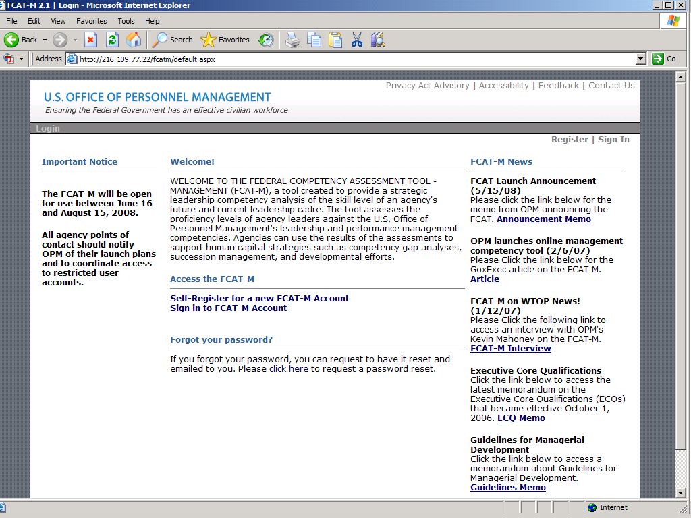

Enter your email address and password in the form provided. Click the “Sign In” button. This will log you in to the FCAT-M.

If you forget your password, click the “Forget your password?” link. Enter your email address and a new password will be emailed to you. Once you receive the new password, log in and change your password to a different one.

3.4 Signing Out
- You may sign out of the FCAT-M by clicking the ‘Sign Out’ link located in one of two places: the Main Menu (left side) and the upper right.

3.5 Changing Your Password
- You may change your password by clicking the ‘Change Password’ link located in the Main Menu (left side). Please remember that your password must be eight characters.

3.6 Conducting a Self Assessment
Note: these instructions are provided to give an indication of what the typical “user” would encounter when conducting a self assessment. Agency POCs will also have access to this functionality, but may or may not participate in the assessment.

- The FCAT-M allows you to conduct a self assessment of your current proficiency on the U.S. Office of Personnel Management leadership and/or performance management competencies (depending on what you selected during registration). Each competency is provided with a definition and generic proficiency (1-5 point) scale. Please select 0 if the competency does not apply to you.

- You may save your assessment at any time by clicking the 'Update' button on the assessment screen. You may also log in at any point in the future to update your assessment.

- Click the “Click here to begin your self-assessment” link.
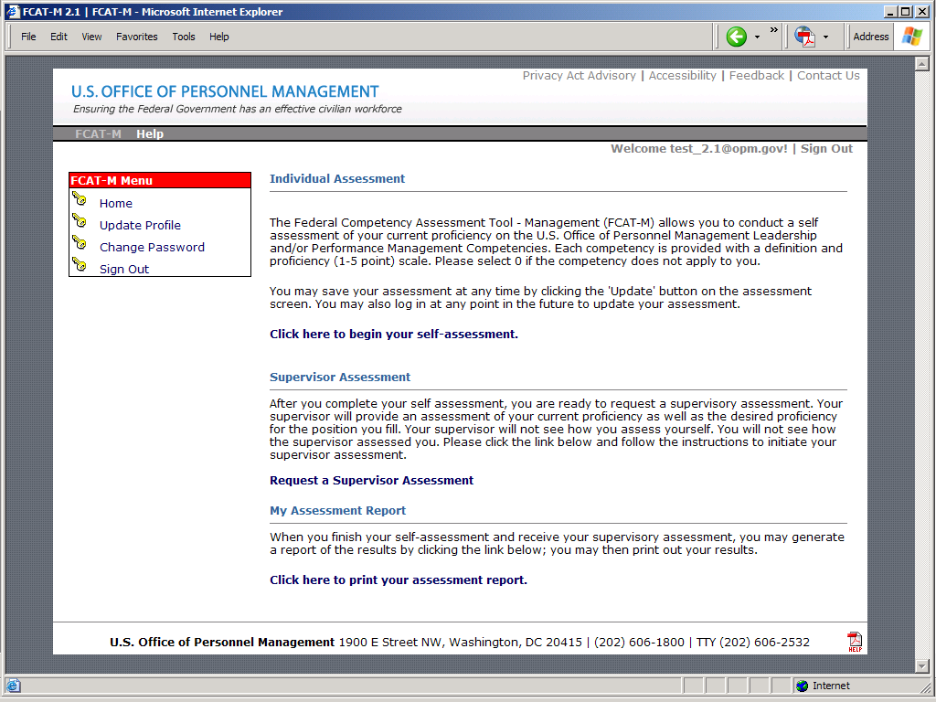

- This will bring up a list of competencies.

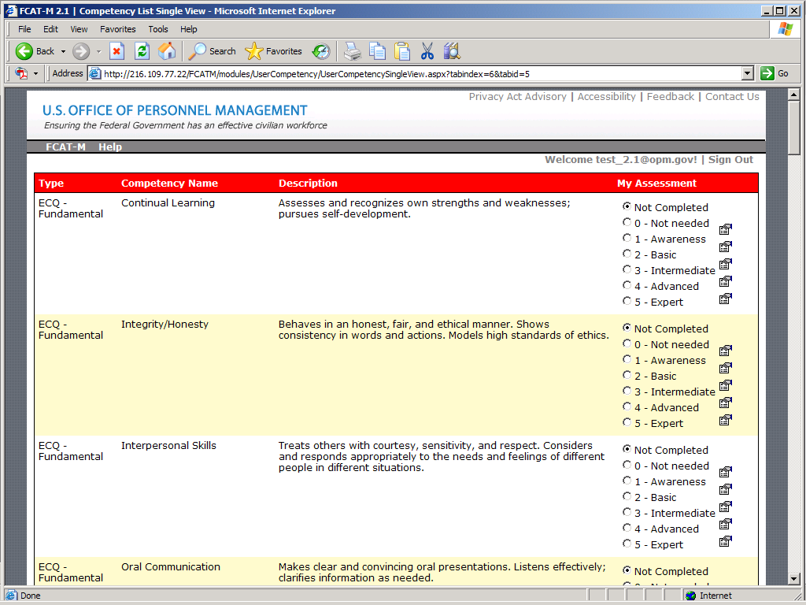

- At the top of the screen is a Competency Filter. You may alter your view by selecting either the Full Set (Leadership and Performance Management) or Only Performance Management options. The competency list includes:

- The type of competency (e.g., ECQ1, performance management)
- Competency name
- Competency description
- Supervisor assessment
- Self-Assessment

- You will complete the column on the far right. To see a description of the level, and a behavioral indicator, for each competency, click on the icon on the right. If a competency is not needed in your role, leave the “Not Needed” option selected. Once you have completed your self-assessment, click “Update” and you will be brought back to the main FCAT-M screen.

3.7 Conducting a Supervisory Assessment
Note: these instructions are provided to give an indication of what the typical “user” would encounter when conducting a supervisory assessment. Agency POCs will also have access to this functionality, but may or may not participate in the assessment.
- After you complete your self assessment, you are ready to receive a supervisory assessment. Your assessment combined with your supervisor's will help identify your strengths and areas for improvement. Please click the “Request a Supervisor Assessment” link and follow the instructions to initiate your supervisor assessment.

- Follow the instructions on the screen to identify the email address and name of your supervisor. Click “Email Request” and your supervisor will receive an email to complete the assessment:

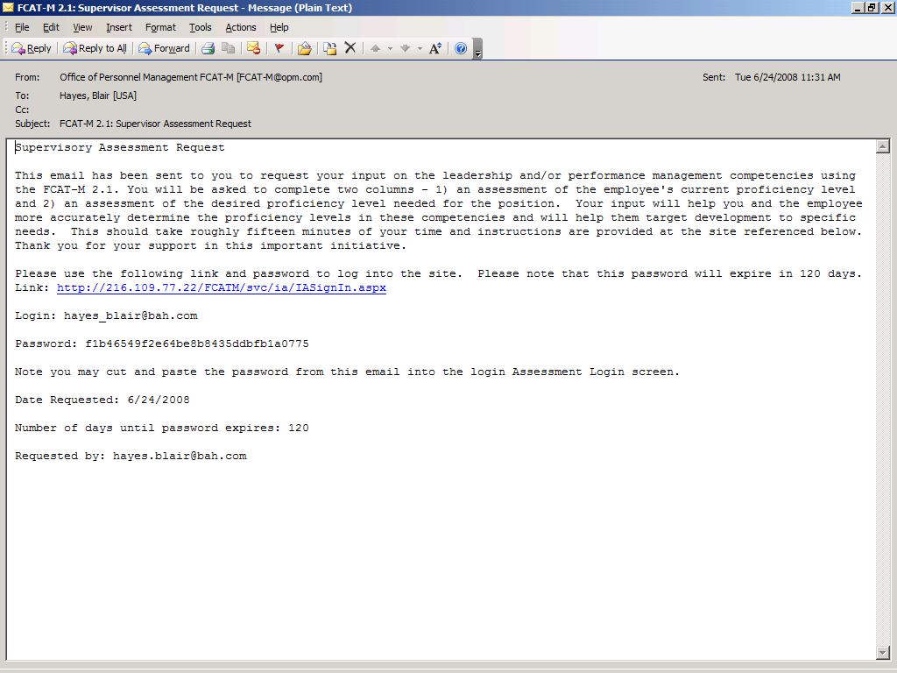

- Your supervisor will not see how you have rated yourself during the assessment. However, after your supervisor conducts their assessment, you should share the result of your assessment so that any discrepancies can be discussed and resolved.

3.8 Assessment Results Report
Note: these instructions are provided to give an indication of what the typical “user” would encounter when they would like to have a printout of the results of the self and supervisor assessment. Agency POCs will also have access to this functionality, but may or may not participate in the assessment.

- When you finish your self-assessment and receive your supervisory assessment, you may generate a report of your results and your supervisory results. Please click the “Click here to print your assessment report” link to access the report.

- You may print your assessment report by using your browser’s print function.

3.9 Additional Features

3.9.1 Main Menu

- You may manage your FCAT-M account by utilizing the FCAT-M menu on the left of the screen. The “Update Profile” link will allow you to update the information that you provided during registration.

- The “Home” link will bring you to the main FCAT-M screen from which you can update your self-assessment, request a supervisory assessment, or view your assessment report.

- You may also Sign Out from the FCAT-M system from this menu.

3.9.2 Help

- By clicking on the “Help” tab at the top left of the screen, you will have access to frequently asked questions, the standard User's Guide and other documentation that will help you get the most out of the FCAT-M and address any questions or problems you might have. As an Agency POC, there may be other documentation that only Agency POCs have access to.

3.9.3 Site Information

- Information related to the FCAT-M site can be found by clicking on the following links located at the top right of your screen:

- Privacy Statement – This link leads to OPM’s privacy policy as it relates to the FCAT-M website. OPM will collect no personal information about you when you visit our website unless you choose to provide that information. The privacy policy also identifies the type of information the system collects and what OPM will do with that information.
- Accessibility – The FCAT-M system is designed to be compliant with Section 508 of the Rehabilitation Act Requirements. This link identifies those requirements.
- Feedback – This link allows you to send feedback to the FCAT-M system administrator. This feedback can be content-related, technical, or other.
- Contact Us – This link identifies a point-of-contact in case of questions, comments, suggestions, or difficulties with the site.

3.10 Accessing Other Reports
As an Agency POC, you have access to other reports that will help you perform analyses and determine participation rates for the assessment. To access reports, click the ‘Reports’ tab in the toolbar, as shown in the image below. If you do not have this tab available, please contact the OPM FCAT-M Project Team.

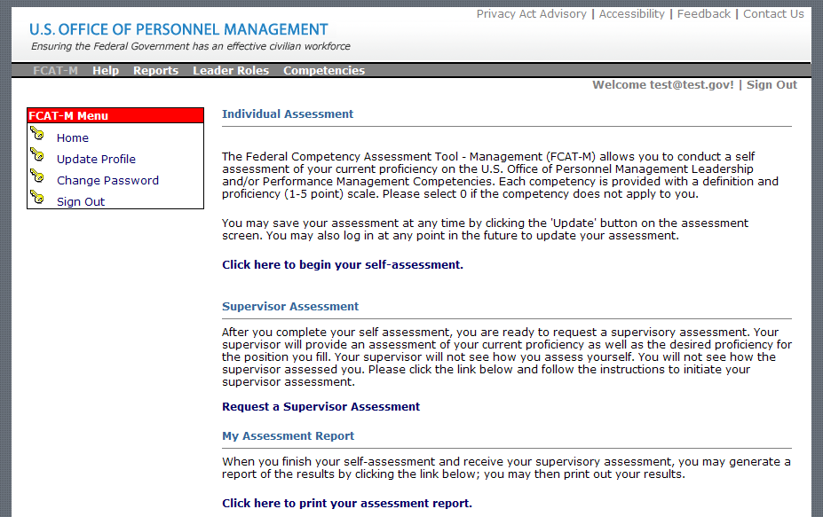

The following image illustrates they categories (e.g., Analysis and Profile) and reports that you may access (subject to change as addition reports are implemented):

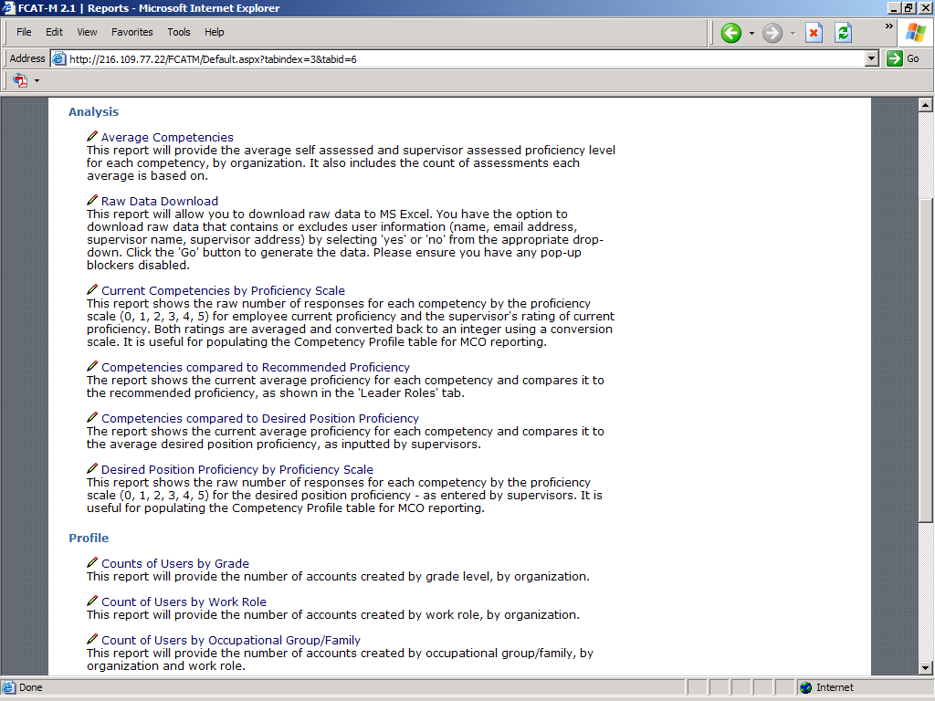

To generate a report, click on the report name link (for example, Average Competencies).

3.10.1 Average Competencies Report

As shown in the illustration below, the Average Competencies Report provides a summary of the results of the competency assessment, by competency (with the associated competency type and definition), averaged by employee (the My Assessment column) and by supervisor (the Supervisor Assessment column), and with a corresponding average between the employee and supervisor ratings (the Assessment Average column). The number of assessments the average is based on is provided in each respective ‘count’ column.

The report can be filtered using the drop down fields for Bureau/Agency, Pay Plan, Grade, Projected Retirement and Work Role. The Agency/Department is generally not user-manipulated. Once you select a value from one or more of the drop downs, the report will refresh with new results based on the filters you select.

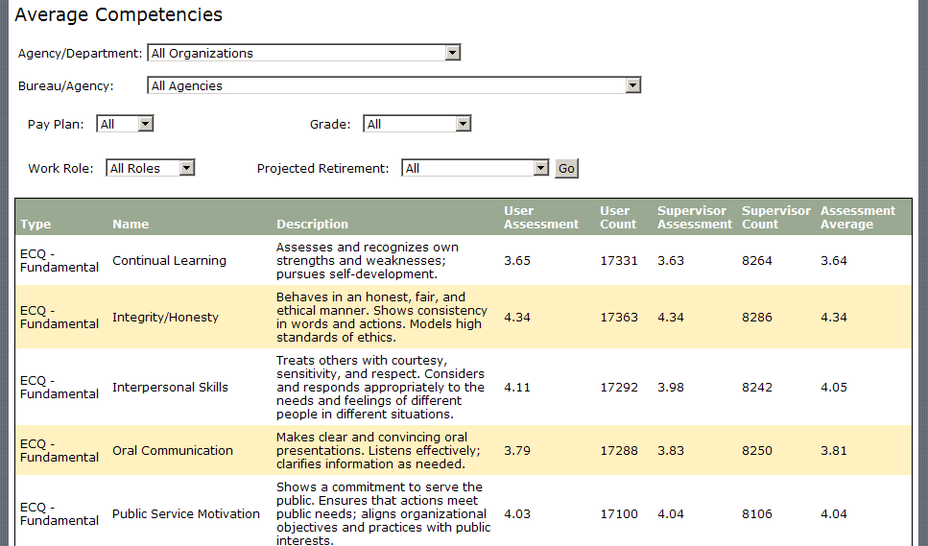

3.10.2 Profile Reports

Use the Profile Reports to get a count of the number of accounts created. Such counts can be reported on in total or by grade, work role, occupational group/family, agency and date. As with the Average Competencies Report, you can filter results by organizational structure and work role.

Appendix A: FCAT-M Assessment Phases and Activities – Activities Checklist

Department/Agency: ________________________________________
Scheduled Launch Date: ________________________________________
Scheduled Completion Date ________________________________________

Complete | Activity | Guide Reference | Lead Role | Comments, Notes, Supporting Details, and Questions
 | Conduct Consultative Meeting with OPM | 2.3.1, p. 6 | OPM
 | Confirm Agency POC(s) | 2.3.1, p. 6 | Agency | The POC(s) for the FCAT-M Assessment effort will be (include POC information):
 | Establish regular status/update meeting schedule | 2.3.1, p. 6 | Shared | Insert meeting details (e.g., location, room number, day/time, conference call numbers) below:
 | Determine if agency will require a “lock down” for the registration process | 2.3.1, p. 6 | Agency | If required, the lock down password for the agency is: __________________________
 | Determine if the agency will assess against the full set or just the performance management competencies | 2.3.1, p. 6 | Agency
 | Develop FCAT-M Assessment Project Plan | 2.3.2, p. 7 | Agency
 | Determine preliminary assessment Launch and Completion dates | 2.3.2, p. 7 | Agency | Enter dates above
 | Establish FCAT-M Account(s) and provide account access information | 2.3.3, p. 7 | OPM | Additional POC(s) requiring account access (include POC information):
 | Access FCAT-M account to ensure it works properly | 2.3.4, p. 8 | Agency | Notify OPM FCAT-M Project Team of any access problems.
 | Identify target population for assessment participation | 2.3.5, p. 8 | Agency | Total estimated target population for assessment participation: __________
 | Determine preferred method for communicating with target population | 2.3.5, p. 8 | Agency | Method:
 | Provide Agency organization level data | 2.3.6, p. 8 | OPM
 | Review Agency organization level data and provide requested changes to OPM | 2.3.6, p. 8 | Agency
 | Identify stakeholder constituencies and their information needs | 2.3.7, p. 9 | Agency | List of stakeholder constituencies:  - _______________________________  - _______________________________  - _______________________________  - _______________________________  - _______________________________  - _______________________________
 | Develop tactical outreach plan | 2.3.7, p. 9 | Agency
 | Assess Union implications | 2.3.8, p. 10 | Agency | Which Union(s) is/are involved?  Are there Union implications? Yes/No
 | Identify course of action to mitigate Union concerns, as appropriate | 2.3.8, p. 10 | Shared | Mitigation strategy:
 | Send assessment Pre-Launch notification email (Appendix B); tailor as appropriate | 2.3.9, p. 10 | Agency
 | Send assessment Launch Day notification email (Appendix B); tailor as appropriate | 2.4.1, p. 10 | Agency
 | Monitor participation and update response rate; communicate to Agency leadership as appropriate | 2.4.2, p. 10 | Agency
 | Provide “first line” assistance to Agency users | 2.4.3, p. 11 | Agency
 | Submit questions, feedback and comments from Agency users to OPM FCAT-M project team, as appropriate | 2.4.3, p. 11 | Agency
 | Send participation reminders | 2.4.4, p. 11 | Agency | Optimal frequency of participation:
 | Send Assessment “Pre-Close” email | 2.4.5, p. 11 | Agency
 | Send Assessment Closure email | 2.4.5, p. 11 | Agency
 | Determine representativeness of assessment sample | 2.5.1, p. 12 | Agency
 | Begin analyses of competency data | 2.5.2, p. 12 | Agency

Appendix B: FCAT-M Communications Kit

B.1 Introduction
This section provides a communications kit that Agency POCs can use as a sample or template when preparing various types of communications about the FCAT-M to current and prospective leaders within the agency workforce. The communications kit provides necessary information and materials to support you as you prepare to launch and oversee the FCAT-M in your Agency.

B.1.1 What is Included in the FCAT-M Communications Kit

The following list details the components of this Communications Kit. Each of the components is discussed below.

1. A sample pre-launch alert e-mail
2. A sample launch day e-mail
3. A sample weekly reminder e-mail
4. A sample assessment pre-closure e-mail
5. A sample assessment closure email
6. Tips for increasing response rates
7. Motivating messages

B.2 Purpose, Instructions and Timing of Communications
The following section outlines the purpose of each element of the communications kit, provides instructions about how to use the materials, and suggests the appropriate timing for implementation of communications kit elements (subject to revision based on how the FCAT-M will be rolled out within a specific Agency).

B.2.1 Pre-Launch E-mail

Purpose: This message gives participating employees a “heads up” the FCAT-M is launching soon.
Instructions: Cut and paste the text (found in Section B.3) into an e-mail message and distribute to participating leadership at least one (1) week prior to the launch of the FCAT-M. Please tailor the language as necessary for your Agency. This communication should not include the URL to the tool.
When to Distribute: Several weeks before your Agency will begin participation.

B.2.2 Launch Day E-mail

Purpose: This message announces that the FCAT-M is now available and provides the link for web access.
Instructions: Cut and paste the text (found in Section B.4) into an e-mail message and distribute to participating employees. Please tailor the language as necessary for your Agency; in particular, you may want to refer to particular incentives your Agency is offering to help bolster participation, if applicable.
When to Distribute: On the first day the FCAT-M is available to your Agency, determined during the consultation process with OPM.

B.2.3 Weekly Reminder E-mail

Purpose: This message reminds individuals to please take the assessment. As you’ll see in this email, we suggest that you include in these weekly reminders your Agency’s current response rate compared to your target response rate. Publicizing the gap between a goal and the current state will often motivate increased participation (you as a POC will be able to track your Agency’s response rate as explained in Section 3.10) .
Instructions: Cut and paste the text (found in Section B.5) into an e-mail message and distribute to participating employees in your Agency. Tailor the language as necessary for your Agency; in particular, be sure to update the response rate information (current verses target) each time you send these communications.
When to Distribute: The Monday of each week that your Agency is conducting the assessment.

B.2.4 Assessment Pre-closure E-mail

Purpose: This message informs individuals in your Agency that the time period for administering the FCAT-M assessment is coming to a close, and may serve as another reminder to participate in the assessment.
Instructions: Cut and paste the text (found in Section B.6) into an e-mail message and distribute to participating employees in your Agency. Please tailor the language as necessary for your Agency; in particular, be sure to update the response rate information (current verses target).
When to Distribute: The Monday prior to the close of the assessment; this may be sent out a week earlier, if preferred, to give two weeks advance notice.

B.2.5 Assessment Closure E-mail

Purpose: This message informs individuals in your Agency that the FCAT-M assessment has ended and thanks them for their participation.
Instructions: Cut and paste the text (found in Section B.7) into an e-mail message and distribute to participating employees in your Agency. Please tailor the language as necessary for your Agency; in particular, be sure to update the final response rate information (current verses target).
When to Distribute: The day of assessment close, which will be determined during the consultation process with OPM.

B.2.6 Tips for Increasing Response Rates

Purpose: This section provides tips and ideas for increasing assessment response rates for the FCAT-M.
Instructions: These tips are provided for informational purposes only and should not be sent out to your workforce. They are found in Section B.8.

B.2.7 Motivating Messages

Purpose: This section provides some messages that can be incorporated into certain email communications to encourage participation and address the “what’s in it for me” for participating employees. You may also provide a copy of the Frequently Asked Questions (Appendix C).
Instructions: Include the motivating messages to various email communications (such as the weekly reminders) as you deem appropriate. They can be found in Section B.9.

B.2.8 Other Points to Remember

- Agencies with existing leadership competency tools are not required to replace those tools with the FCAT-M.
- While Agencies may set target response rate goals, the use of the FCAT-M is voluntary.

B.3 Pre-Launch Email
Dear Agency Leader,

[Insert Agency Leader’s Name] and I recognize the important role you play in leading our key initiatives and meeting our mission and strategic priorities. We also recognize the increased demands on you and your staffs. Ensuring you have the necessary skills to do your job is key to your success and to our meeting current and future business needs.

In the next few weeks, you will be asked to complete a self-assessment of your current skill level in key leadership competencies and and/or performance management competencies that have been identified as most critical and urgent for leaders and managers. The self-assessment is for developmental purposes only and will ensure we are focusing on the training and development programs necessary to meet your needs and our agency objectives.

When you receive the assessment, please complete it as quickly as possible. Our goal is to have all assessments completed by [INSERT DATE]. To support us in this effort, the Office of Personnel Management has developed a Web-based assessment tool called the Federal Competency Assessment Tool - Management (FCAT-M) for us to use. The Web-based tool will allow you to self-register and assess yourself against the competencies. Your supervisor will also provide his/her assessment of your skill level in these areas.

In [INSERT DATE], you will receive another message that will include a schedule of when to complete the assessment, the Web link to the assessment tool, and job aids to help complete the assessment. Attached to this email are some answers to questions you may have about the FCAT-M.

If you need additional information, please contact [contact name and information here].

Again, I would like to thank you for the work you do and remind you of the important role you play in meeting our mission.

Sincerely,

[Insert POC’s Name]

The information below should be attached to the above email message:

Federal Competency Assessment Tool – Management (FCAT-M)

Questions and Answers

WHAT IS the FCAT-M?

The FCAT-M is a web-enabled leadership assessment and development tool for current and prospective Federal leaders. The new tool is called the Federal Competency Assessment Tool - Management (FCAT-M). The FCAT-M is intended for developmental purposes only and is not meant as a performance management tool.

Who should Participate?

Federal leaders, including executives, managers, supervisors, team leaders, and others the agency has determined as management candidates or potential leaders. When assessing individual who are considered management candidates or potential leaders, the agency must ensure merit principles were observed in their selections as management candidates or potential leaders.

What is the purpose of the FCAT-M?

The FCAT-M is part of [our Agency’s] efforts to strategically plan for and sustain a high performance leadership cadre. The FCAT-M will allow us to understand the strengths and developmental needs of this cadre across an array of leadership and performance management competencies so informed investment decisions are made. Again, the FCAT-M is not a tool used to support performance management/assessment processes.

How will the results be used?

The results of the FCAT-M will be used to guide individual leadership development for current and prospective leaders in our organization and will also provide data on general strengths and areas of need. Ultimately, these results will be valuable inputs into our human capital planning efforts.

How can you participate?

Once the FCAT-M is launched, you will receive a separate email notification that will allow you to access the tool and conduct an individual assessment and request input for a supervisory assessment. A link to the web-based FCAT-M assessment tool will also be included. The on-line assessment will take about 15 minutes to complete. The deadline to complete your assessment will also be provided. We strongly urge you to complete the assessment. This is a great opportunity for you to gather information on critical areas to focus your individual development as well as to plan to meet your needs as a manager; in addition, it will provide valuable input to our organization to help in our human capital planning efforts.

Thank you in advance for your participation. We understand that there are many things competing for your limited time. We are also certain that completing the assessment will be to your advantage.

If you have questions about the assessment, you should first contact the POC within our Agency: [INSERT NAME AND POC INFORMATION]. Alternatively, you may contact our Agency’s Human Capital Officer [INSERT NAME AND POC INFORMATION].

B.4 Launch Email
Today is the start of our management competency assessment. This self-assessment is for developmental purposes only and will help ensure we are building the training and development programs necessary to meet your needs and our agency objectives.

The FCAT-M is a web-enabled leadership assessment tool for current and prospective Federal leaders. You are invited to participate by completing a self assessment and getting your supervisor to provide an assessment as well. You may access the assessment tool by visiting https://fcat.opm.gov. You must complete a self-registration process prior to taking the assessment. [IF THERE ARE ADDITIONAL AGENCY-SPECIFIC PASSWORDS, THEY SHOULD BE INCLUDED HERE.] Keep in mind that some of the registration information is mandatory and some is optional. We encourage you to complete the optional information, as it will help us greatly in our planning efforts.

The assessment will take you about 15 minutes to complete. Once your self assessment is complete, you will need to request input from your supervisor. Please complete the assessment by [INSERT ASSESSMENT CLOSE DATE.]

The FCAT-M is part of our efforts to strategically plan for and sustain a high performance leadership cadre. The FCAT-M will allow us to understand the strengths and development needs of this cadre across an array of leadership and performance management competencies so that informed investment decisions can be made.

As an agency leader , the results of the assessment will enable you to identify competency strengths and areas for improvement and tailor leadership development plans to meet your specific needs.

Please make time to complete the assessment. If you have questions about the assessment, you should first contact the POC within our Agency: [INSERT NAME AND POC INFORMATION]. Alternatively, you may contact our Agency’s Human Capital Officer [INSERT NAME AND POC INFORMATION].

B.5 Weekly Reminder E-mail
Don’t forget that we’ve launched the Federal Competency Assessment Tool - Management (FCAT-M) We encourage you to take this opportunity to complete an assessment and identify your competency strengths and areas of improvement. You should also have a supervisory assessment completed so you have a full picture of your current level of proficiency.

The FCAT-M is available on-line until [DATE] and can be accessed at: https://fcat.opm.gov.

Currently, our response rate is [#]% and our target response rate is [#]%. Please take the time to complete your assessment today!

B.6 Assessment Pre-Closure Email
Thanks to those of you who have completed your management assessment using the Federal Competency Assessment Tool – Management (FCAT-M). The assessment is a great resource to help you identify your competency strengths and areas of improvement as you continue in your leadership development. The survey will only be open for [X] more days. If you have not completed your assessment or still need to have your supervisor complete theirs, please do by [date]. You may access the FCAT-M by clicking on https://fcat.opm.gov.

Currently, our response rate is [#]% and our target response rate is [#]%. Please be sure to complete all assessments soon!

B.7 Assessment Closure Email
Our management FCAT-M competency assessment period has concluded. Thanks to all of you who completed an assessment. We know you will find the results a useful resource to guide your leadership development.

Our final response rate was [#]% and our target response rate was [#]%. Thank you for participating!

We will let you know of any opportunities in the future to conduct this assessment again. If you have questions about the assessment, you should first contact the POC within our Agency: [INSERT NAME AND POC INFORMATION]. Alternatively, you may contact our Agency’s Human Capital Officer [INSERT NAME AND POC INFORMATION].

B.8 Tips for Increasing Response Rates
- Reward employees for completing their assessment

- Remind employees that this tool is only being used for development purposes, not for performance management (employees may see that there are performance management competencies in the tool and infer that there is a performance management component to the tool; however, this is false).

- Set aside a time and day (2 hour period) where all participants should have no other responsibility than completing the assessment

- Personal contact –Agency POC to make calls, visits, announcements in meetings

- Drawing – lunch with [Agency leader] (to enter – must show proof of completed assessment)

- Send all reminder messages in Communications Kit

- Find other opportunities to stress the benefits (e.g., demonstrations, brown bags, team meetings)

- Set up a fun challenge with another agency

B.9 Motivating Messages
Message 1:

Complete an Assessment and You Benefit!

The Federal Competency Assessment Tool - Management is now available!

Top 5 Reasons Why Employees Want to complete an assessment using the FCAT-M:

5. I think it’s cool to use the web-based tool.
4. All of my colleagues in leadership positions are taking it!
3. I want to help reach our goal of a X% response rate!
2. I want to support my agency in this initiative.

And the number one reason for completing an assessment on FCAT-M…

1. I want to proactively focus on my career development and ensure our agency has the best leaders.

You too can make a difference by completing this assessment!!
https://fcat.opm.gov

Message 2:

The FCAT-M – for Federal Leaders!

The Federal Competency Assessment Tool - Management is now available from [dates]!

Help Us, Help You!

Do you want our agency to have a cutting edge leadership?
Do you want to be a part of this leadership?
Do you want to proactively manage your own career development so you can be a great leader?

Then go to https://fcat.opm.gov to help us, help you.

Message #3:

What’s On Your Mind (WOYM) or “The Three Ps”

1. Purpose

The purpose of the FCAT-M is to measure the skill level of current and prospective leaders. Agencies can use the results of the assessments to support their gap analyses, succession plans, and developmental efforts. The FCAT-M will enable our agency to strategically plan for and sustain a high performance leadership cadre. The FCAT-M will allow us to understand the strengths and development needs of this cadre across an array of leadership and performance management competencies so that informed investment decisions can be made.

2. Personal Benefit

There are several benefits to you by completing this assessment:
- You can identify your competency strengths
- You can identify your areas of improvement
- You can tailor your individual development plan based on needed competencies
- You can have your supervisor provide valuable feedback about your skill level!

3. Payoff

The assessment you complete will guide you in your leadership development and help you identify appropriate resources to help you meet your career goals. In addition, the data will help our agency define leadership needs, develop action plans to address identified gaps, and plot a course toward desired employee development and organizational outcomes and improvements.

Appendix C: Frequently Asked Questions

- WHAT IS THE FCAT-M? The Federal Competency Assessment Tool - Management (FCAT-M) is a Web-based instrument for assessing the proficiency levels of management candidates in leadership and performance management competencies. The FCAT-M uses Executive Core Qualifications and performance management competencies (34 competencies in all). The FCAT-M obtains assessments from both individual and supervisory levels.

- WHAT IS THE WEBSITE ADDRESS? The FCAT-M can be accessed at https://fcat.opm.gov.

- WHAT IS THE PURPOSE OF THE FCAT-M? The FCAT-M is part of [our Agency’s] efforts to strategically plan for and sustain a high performance leadership cadre. The FCAT-M will allow us to understand the strengths and development needs of this cadre across an array of leadership and performance management competencies so that informed investment decisions can be made.

- WHO SHOULD TAKE THE FCAT-M ASSESSMENT? The FCAT-M is available to all Federal agencies. The target audience for the FCAT-M is:

- Managers and supervisors (as designated in the Central Personnel Data File)
- Employees who are determined to be candidates for management, supervisory or leadership positions, provided merit principles were observed in those determinations.
- Agencies can designate other groups, such as team leaders or executives, to use the FCAT-M.

- HOW DO I GET MORE INFORMATION ABOUT THE FCAT-M? The OPM point of contact is Angela Graham Humes at 202-606-2430 or email at Angela.GrahamHumes@opm.gov.

- IS THE FCAT-M A TOOL FOR ASSESSING PERFORMANCE? No. The FCAT-M is only being used for development purposes, not for performance management. While you may notice that there are performance management competencies in the tool, you should not infer that there is a performance management component to the tool.

- WILL MY SUPERVISOR ASSESS ME? Yes, an important part of the FCAT-M assessment is the input from your supervisor. Remember, this is for developmental purposes only.

- Do I need an account to take the assessment? No pre-created account is necessary. The system requires self-registration for the assessment. To start the assessment process, go to the Website and select the Click Here to Register link.

Appendix D: Competencies and Rating Scales

D.1 Leadership Competencies
The table below documents the Leadership competencies (based on the Office of Personnel Management’s Executive Core Qualifications (ECQs)) that are included in the assessment.

# | Type | Competency | Definition
1 | ECQ 1 – Leading Change | Creativity | Develops new insights into situations; questions conventional approaches; encourages new ideas and innovations; designs and implements new or cutting edge programs/processes.
2 | ECQ 1 – Leading Change | External Awareness | Understands and keeps up-to-date on local, national, and international policies and trends that affect the organization and shape stakeholders' views; is aware of the organization's impact on the external environment.
3 | ECQ 1 – Leading Change | Flexibility | Is open to change and new information; rapidly adapts to new information, changing conditions, or unexpected obstacles.
4 | ECQ 1 – Leading Change | Resilience | Deals effectively with pressure; remains optimistic and persistent, even under adversity. Recovers quickly from setbacks.
5 | ECQ 1 – Leading Change | Strategic Thinking | Formulates objectives and priorities, and implements plans consistent with the long-term interests of the organization in a global environment. Capitalizes on opportunities and manages risks.
6 | ECQ 1 – Leading Change | Vision | Takes a long-term view and builds a shared vision with others; acts as a catalyst for organizational change. Influences others to translate vision into action.
7 | ECQ 2 – Leading People | Conflict Management | Encourages creative tension and differences of opinions. Anticipates and takes steps to prevent counter-productive confrontations. Manages and resolves conflicts and disagreements in a constructive manner.
8 | ECQ 2 – Leading People | Leveraging Diversity | Fosters an inclusive workplace where diversity and individual differences are valued and leveraged to achieve the vision and mission of the organization.
9 | ECQ 2 – Leading People | Developing Others | Develops the ability of others to perform and contribute to the organization by providing ongoing feedback and by providing opportunities to learn through formal and informal methods.
10 | ECQ 2 – Leading People | Team Building | Inspires and fosters team commitment, spirit, pride, and trust. Facilitates cooperation and motivates team members to accomplish group goals.
11 | ECQ 3 – Results Driven | Accountability | Holds self and others accountable for measurable high-quality, timely, and cost-effective results. Determines objectives, sets priorities, and delegates work. Accepts responsibility for mistakes. Complies with established control systems and rules.
12 | ECQ 3 – Results Driven | Customer Service | Anticipates and meets the needs of both internal and external customers. Delivers high-quality products and services; is committed to continuous improvement.
13 | ECQ 3 – Results Driven | Decisiveness | Makes well-informed, effective, and timely decisions, even when data are limited or solutions produce unpleasant consequences; perceives the impact and implications of decisions.
14 | ECQ 3 – Results Driven | Entrepreneurship | Positions the organization for future success by identifying new opportunities; builds the organization by developing or improving products or services. Takes calculated risks to accomplish organizational objectives.
15 | ECQ 3 – Results Driven | Problem Solving | Identifies and analyzes problems; weighs relevance and accuracy of information; generates and evaluates alternative solutions; makes recommendations.
16 | ECQ 3 – Results Driven | Technical Credibility | Understands and appropriately applies principles, procedures, requirements, regulations, and policies related to specialized expertise.
17 | ECQ 4 – Business Acumen | Financial Management | Understands the organization's financial processes. Prepares, justifies, and administers the program budget. Oversees procurement and contracting to achieve desired results. Monitors expenditures and uses cost-benefit thinking to set priorities.
18 | ECQ 4 – Business Acumen | Human Capital Management | Builds and manages workforce based on organizational goals, budget considerations, and staffing needs. Ensures that employees are appropriately recruited, selected, appraised, and rewarded; takes action to address performance problems. Manages a multi-sector workforce and a variety of work situations.
19 | ECQ 4 – Business Acumen | Technology Management | Keeps up-to-date on technological developments. Makes effective use of technology to achieve results. Ensures access to and security of technology systems.
20 | ECQ 5 – Building Coalitions | Partnering | Develops networks and builds alliances; collaborates across boundaries to build strategic relationships and achieve common goals.
21 | ECQ 5 – Building Coalitions | Political Savvy | Identifies the internal and external politics that impact the work of the organization. Perceives organizational and political reality and acts accordingly.
22 | ECQ 5 – Building Coalitions | Influencing/Negotiating | Persuades others; builds consensus through give and take; gains cooperation from others to obtain information and accomplish goals.
23 | ECQ - Fundamental | Interpersonal Skills | Treats others with courtesy, sensitivity, and respect. Considers and responds appropriately to the needs and feelings of different people in different situations.
24 | ECQ - Fundamental | Oral Communication | Makes clear and convincing oral presentations. Listens effectively; clarifies information as needed.
25 | ECQ - Fundamental | Integrity/Honesty | Behaves in an honest, fair, and ethical manner. Shows consistency in words and actions. Models high standards of ethics.
26 | ECQ - Fundamental | Written Communication | Writes in a clear, concise, organized, and convincing manner for the intended audience.
27 | ECQ - Fundamental | Continual Learning | Assesses and recognizes own strengths and weaknesses; pursues self-development.
28 | ECQ - Fundamental | Public Service Motivation | Shows a commitment to serve the public. Ensures that actions meet public needs; aligns organizational objectives and practices with public interests.

D.2 Performance Management Competencies
The table below documents the performance management competencies that are included in the assessment.

# | Type | Competency | Definition
1 | Performance Management | Understanding Performance Management Processes and Practices | Understands and works within the context of the performance appraisal system to actively manage self and others.
2 | Performance Management | Goal Setting | Sets and maintains effort toward goals by establishing measurable results that support organizational mission accomplishment.
3 | Performance Management | Performance Coaching and Feedback | Initiates and engages in performance-related conversations with others to support continual professional and personal growth.
4 | Performance Management | Facilitating Performance | Initiates and guides the efforts of self and others toward performance goals through ongoing support, removal of performance obstacles, managing consequences, and holding employees accountable.
5 | Performance Management | Differentiating Performance | Makes fair assessments of performance based upon measures of performance that include observable behaviors, performance feedback and demonstrated result.
6 | Performance Management | Building Performance Culture | Creates an environment that fosters and rewards teamwork, leverages diversity, shares knowledge and resources, inspires collaboration and promotes results-focuses mission accomplishment.

D.3 Generic Proficiency Rating Scale
The table below documents the proficiency rating scale that will be used by all assessment participants to rate the current proficiency in the listed competencies. This generic scale will be used until behavioral indicators have been developed for each competency (at which point the generic scale will be replaced).

# | Proficiency Level | Definition
0 | Not needed | - Competency is not needed for the job
1 | Awareness | - Applies the competency in the simplest situations  - Requires close and extensive guidance
2 | Basic | - Applies the competency in somewhat difficult situations  - Requires frequent guidance
3 | Intermediate | - Applies the competency in difficult situations  - Requires occasional guidance
4 | Advanced | - Applies the competency in considerably difficult situations  - Generally requires little or no guidance
5 | Expert | - Applies the competency in exceptionally difficult situations  - Serves as a key resource and advises others

D.4 Proficiency Conversion Scale
The table below shows how the Generic Proficiency Rating Scale is converted into the actual level for reporting purposes.

Level | Conversion Scale
Awareness | 1 – 1.4
Basic | 1.5 – 2.4
Intermediate | 2.5 – 3.4
Advanced | 3.5 – 4.4
Expert | 4.5 – 5.0

** N/A Responses do not get averaged into scores (i.e. If an employee assesses themselves as a “3” and the supervisor rates the employee as “N/A,” the assessment will be a “3.”

Appendix E: Demographic Questions for Registration

The table below shows the user account registration and demographic questions that will be presented to assessment participants as they are registering. If applicable, the variables that are associated with each question are listed. These variables are standardized and presented to the participant as options to choose from. In some cases, the participant will have the ability to enter in their own data rather than picking from the available variables (and labeled as ‘User entered’). This elements listed with an asterisk (*) are considered mandatory. Questions are not necessarily listed in the order presented to the user.

Question | Variables
Step 1
*Email address (User ID) | User entered
*Password | User entered
*Re-Enter Password | User entered
*Last Name | User entered
Middle Initial | User entered
*First Name | User entered
*Work Role | Supervisor  Manager  Executive  Team Lead  Other
*Department/Agency | Varies
*Bureau/Agency | Varies
*Sub-Agency/Office | Varies
*Occupational Group/Family | GS-0000 – Miscellaneous Occupations  GS-0100 – Social Science, Psychology and Welfare  GS-0200 – Human Resources Management  GS-0300 – General Administrative, Clerical and Office Services  GS-0400 – Biological Sciences  GS-0500 – Accounting and Budget  GS-0600 – Medical, Hospital, Dental and Public Health  GS-0700 – Veterinary Medical Science  GS-0800 – Engineering and Architecture  GS-0900 – Legal and Kindred  GS-1000 – Information and Arts  GS-1100 – Business and Industry  GS-1200 – Copyright, Patent and Trademark  GS-1300 – Physical Sciences  GS-1400 – Library and Archives  GS-1500 – Mathematics and Statistics  GS-1600 – Equipment, Facilities, and Services  GS-1700 – Education  GS-1800 – Investigation  GS-1900 – Quality Assurance, Inspection and Grading  GS-2000 – Supply  GS-2100 – Transportation  GS-2200 – Information Technology
*Pay Plan | GS  ES  EX  O  W  WO  WD  WG  WL  WN  WS  Other  SV  FS  EV  FV  FG
*Grade | 01  02  03  04  05  06  07  08  09  11  12  13  14  15  16  17  18  19  1E  2E  3E  I  II  III  IV  V  Other  C  D  E  F  G  J  K  L  OC  MC  H
Step 2
Address | User entered
City | User entered
State/Province | User entered
Zip Code | User entered
Country | User entered
Telephone | User entered
Step 3
Highest Level of Education Achieved | High School/GED  Associates Degree  Bachelors Degree  Masters Degree  Ph.D.  Other
Years of Professional Service | Less than 1 Year  1-3 Years  4-6 Years  7-10 Years  11-20 Years  21+ Years  Unknown/Undecided
Years of Service in Government | Less than 1 Year  1-3 Years  4-6 Years  7-10 Years  11-20 Years  21+ Years  Unknown/Undecided
Projected Retirement | Less than 1 Year  1-3 Years  4-6 Years  7-10 Years  11-20 Years  21+ Years  Unknown/Undecided

Note: results of all reports will vary based on the number of registered users, and the number of completed individual and supervisory assessments.

